**ROHAN NYATI**

**500075940**

**R177219148**

**BATCH – 5 (AI & ML)**

**ASSIGNMENT – 1**

Dimensions of wellness

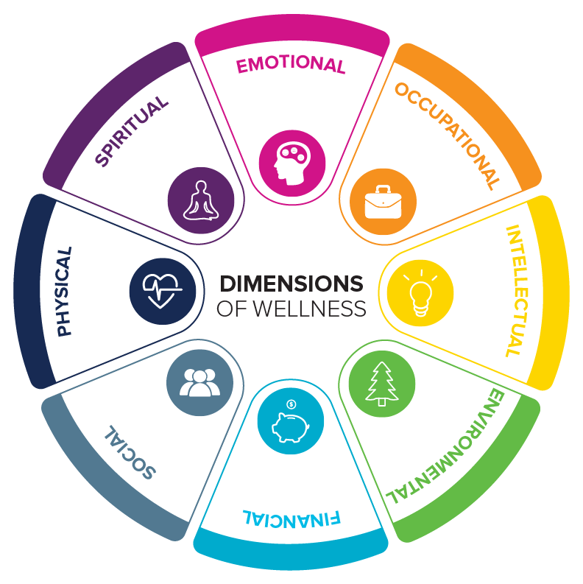

|  |
| --- |
| **Physical Dimension**   * Caring for your body to stay healthy now and in the future   **Intellectual Dimension**   * Growing intellectually, maintaining curiosity about all there is to learn, valuing lifelong learning, and responding positively to intellectual challenges * Expanding knowledge and skills while discovering the potential for sharing your gifts with others   **Emotional Dimension**   * Understanding and respecting your feelings, values, and attitudes * Appreciating the feelings of others * Managing your emotions in a constructive way * Feeling positive and enthusiastic about your life   **Social Dimension**   * Maintaining healthy relationships, enjoying being with others, developing friendships and intimate relations, caring about others, and letting others care about you * Contributing to your community   **Spiritual Dimension**   * Finding purpose, value, and meaning in your life with or without organized religion * Participating in activities that are consistent with your beliefs and values   **Vocational Dimension**   * Preparing for and participating in work that provides personal satisfaction and life enrichment that is consistent with your values, goals, and lifestyle * Contributing your unique gifts, skills, and talents to work that is personally meaningful and rewarding   **Financial Dimension**   * Managing your resources to live within your means, making informed financial decisions and investments, setting realistic goals, and preparing for short-term and long-term needs or emergencies * Being aware that everyone’s financial values, needs, and circumstances are unique   **Environmental Dimension**   * Understanding how your social, natural, and built environments affect your health and well-being * Being aware of the unstable state of the earth and the effects of your daily habits on the physical environment * Demonstrating commitment to a healthy planet |